Practi e for github
Q1)brnaches
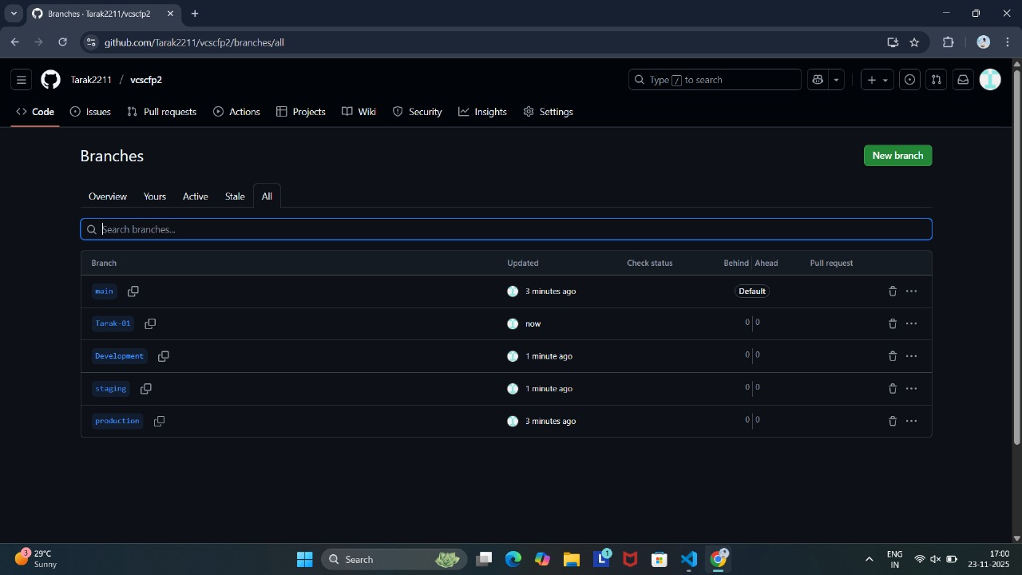
Q2)branch banai vs ma aee batai
